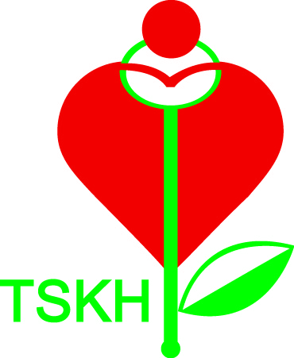
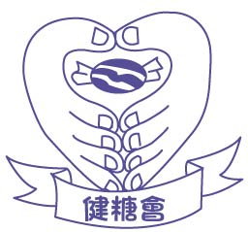
律敦治及鄧肇堅醫院
Ruttonjee & Tang Shiu Kin Hospitals

健糖會
“Kin Tong” Diabetes Club
律敦治及鄧肇堅醫院糖尿病人互助小組於一九九七年九月成立，並於一九九八年八月正式命名為「健糖會」，由醫護人員及病友以義務形式安排活動、講座、展覽等。
The RHTSK Diabetes Patient Support Group was founded in Sep 1997 by volunteered medical staff & people with diabetes, offering a variety of activities, seminars & exhibitions etc. It was named as RHTSK “Kin Tong” Diabetes Club in Aug 1998.

目標 (Mission)
１）提高糖尿病患者及其家人對糖尿病的認識，並以正確態度面對病患。
Provide the diabetes knowledge for patients and their care givers to enhance the positive attitude
toward diabetes.
２）透過分享提昇患者的互助精神。
Develop peer support through sharing.
３）提供社區資源和社會福利等資訊予病者。
Provide information of community resources and social welfare to patients.
４）增強醫護人員與患者的溝通。
Enhance the communication between medical staff and patients.
活動 (Activities)
１）健康講座 (Health Talk)
定期舉辦由醫護專業人士主講的健康講座。
Health talks will be held regularly and medical professionals are invited to be the speaker.
２）聯誼活動 (Gathering)
定期舉辦旅遊、比賽及節日聯歡活動等，以增進會員間之聯繫。
Activities (tours, competition, festival parties......) will be held regularly.
３）健糖會刊物 (Newsletter)
每兩個月出版一次資訊性刊物，以增加會員間的溝通及發放本會資訊。
Newsletter will be published every two months for enhancing the communication within members.
健糖會討論區 (Diabetes Forum)
http://www.healthyhkec.org/healthcare/diabetes care/rhtsk

律敦治及鄧肇堅醫院
Ruttonjee & Tang Shiu Kin Hospitals

「健糖會」申請表格
Application Form of “Kin Tong” Diabetes Club

歡迎所有於本院糖尿科覆診之病友入會，會費全免。請填妥下列表格連同2張相片到健康資源中心入會。
All DM out-patient of Ruttonjee and Tang Shiu Kin Hospitals are welcomed to join us. Membership is free. Please fill in the form and send it back to Health Resource Centre with 2 photos for application.

請用正楷填寫 (Please write in BLOCK letter)
中文姓名 (Name in Chinese)
英文姓名 (Name in English)
身份證號碼 (ID Card No.)
出生日期 (Date Of Birth) |  | 年 (Year) 月 (Month) 日 (Date)
性別 (Sex) |  | 男 Male / 女 Female
電話號碼  Tel. No. | 手提 (Mobile)
電話號碼  Tel. No. | 住宅 (Residence)
電話號碼  Tel. No. | 公司 (Office)
通訊地址
(Correspondence Address)
電郵地址 (E-mail Address)
患病年份(Year with Diabetes)
會員類別 (Category) |  | □ 患者  □ 家屬 | Person with Diabetes Mellitus  Relatives of People with DM
治療方法 (Treatment) |  | □ 飲食控制  □ 口服降糖藥  □ 注射胰島素 | Diet Control alone  Oral Anti-DM Agents  Insulin Injection
有興趣參加項目  (I am interested in) |  | □ 義工服務  □ 通訊製作  □ 健康講座  □ 旅遊  □ 聯誼活動  □ 健糖會討論區 | Volunteer Service  Newsletter Editing  Health Talks  Tours  Gatherings  Diabetes Forum on Website
保密及同意書 (Confidential & Consent)

本人於上述提供的個人資料只作病友小組活動用途。
My personal information above will only be used for PSG activities.

申請人簽名 (Signareof applicant)： 日期 (Date)：

聯絡我們 (Contact us)
健康資源中心 (Health Resource Centre)
中心地址(Address)：香港灣仔皇后大道東266號律敦治醫院5樓C座
5C, Ruttonjee Hospital, 266 Queen’s Road East, Wan Chai, HK
電話號碼 (Tel. No.)：2291 2511
傳真號碼 (Fax No.)：2291 1047

